**PHP Tag:**

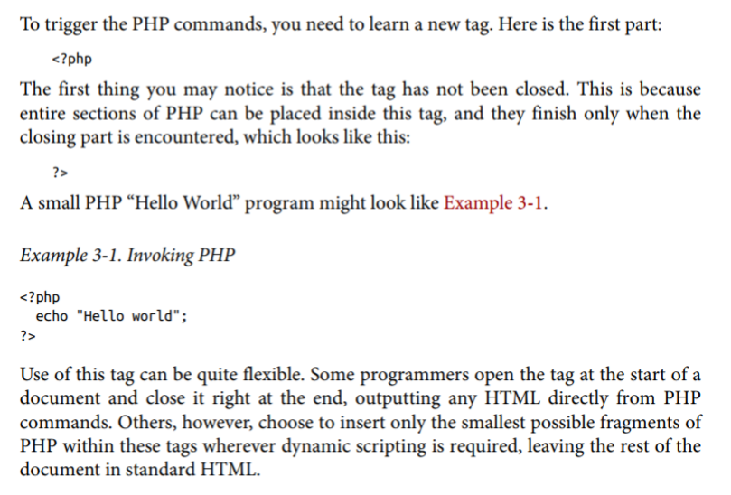

* But in Laravel blade it’s a bit simpler, we can just use **{{ }}** double curly braces and place the variable in side that.
* Blade is the template engine of Laravel. Behind the scenes it transcompile to raw php syntax

 equivalent to 

**If-else:**

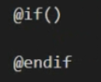

**Loop:**

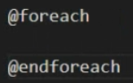

**@csrf:** this creates a hidden field in the form with csrf token to prevent csrf attacks.

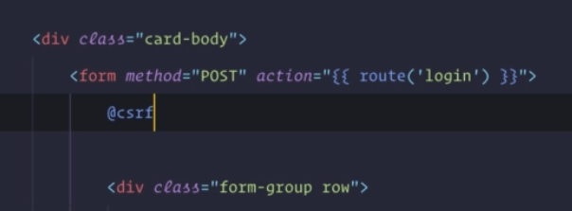

* In case we want to escape what’s inside the we can use !! symbol